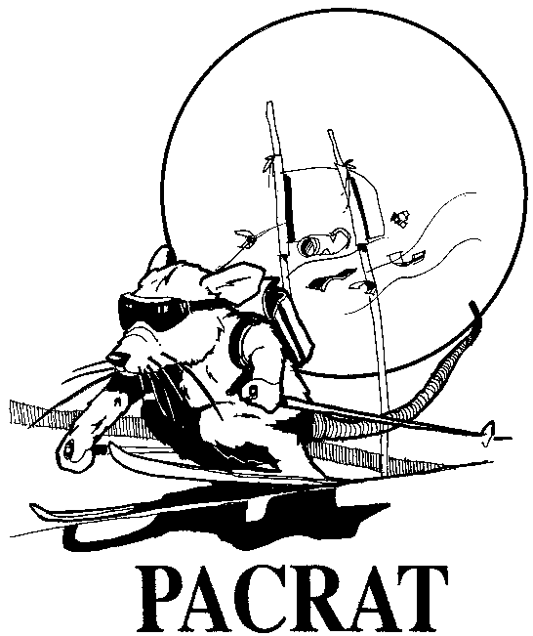
PACRATS

Pacific NW Area Clubs Recreational Alpine Teams

2975 SW Raleighview Drive
Portland, Oregon 97225
August 16, 2004 503-975-4488
email: jfolliard@comcast.net

Hello NWSCC Club Race Reps and Team Captains!!!

The 2005 PACRAT race season is just around the corner and now is the time to get your teams lined up for another exciting season. Snowboarders are allowed just like last year and will receive a 10% time discount per Nastar guidelines.

Included are the team entry form, release and registration guidelines. Please note the deadline for returning the completed entry and release form is December 15, 2004.

Racer fee remains at $85! Still a bargain and the best buy on the mountain – 5 races, post race parties, the famous Rat Attack, discounted lift tickets and plenty of prizes and awards. Nothing beats this program!!!!

And, the special incentive promotion will be continued this year. Pacrats will rebate directly to your club $25 per racer for any net additional team your club registers above the number of teams your club registered last year!!

We are also proud to announce that G.I. Joe’s will again be PACRAT’s primary corporate sponsor. Look for some great prizes this season!

One of PACRAT’s best features is that our program allows for and welcomes all levels of skiing and snowboarding ability. We have seven categories each for men and women ranging from beginner to elite. PACRAT’s handicapping and scoring system encourage varying the skiing/snowboarding levels of the racers on each team of ten individuals.

If a club is unable to completely fill a team with ten (10) racers, please let the Board know!! Last year partial teams from different clubs were combined, thereby providing the racers with a better chance to be on a winning team! It worked well, and this practice will continue in the coming season.

Teams will again race as a team unit. The start order of the season’s first race is determined by lottery, and subsequent race start orders are determined by team standings. Two courses run simultaneously, giving PACRAT racers an opportunity to race against someone. (Remember though, each racer is competing against the clock – not one another.)

Race results will again be emailed to your team captain and available on NWSCC’s Webpage: www.nwskiers.org.

World Headquarters Hotline 503-796-1112 is available throughout the race season with information about race dates, parties, and race day weather issues. PACRAT Board members monitor the weather and snow conditions up to and including the morning of each race. The Hotline will be updated with important changes, as soon as they become known. Please encourage all racers to use the Hotline 503-796-1112.

2005 PACRAT RACE SCHEDULE

Sunday, January 9 Meadows
Sunday, January 23 Timberline
Sunday, February 13 Meadows
Sunday, March 13 Ski Bowl
Sunday, April 3 Meadows
Sunday, April 10 make-up date

Rat Attack - Friday, April 22

The following information is important for each Club Rep and Team Captain:

- Mandatory Team Captain's Kick-off and Bib Pick-up is scheduled for Monday, December 20, 2003, at Roses and Raindrops (same location as last year). Team captains, or their designees, must attend this meeting to pick-up team bibs, learn of any final changes, meet the Pacrat Board, and share in the excitement of the coming season.

- Possible race cancellations It is the responsibility of each Team Captain to confirm whether a scheduled race is being held or cancelled. Call the World Headquarters Hotline, 503-796-1112 the day before a race, and depending upon weather conditions, even on the morning of a race. Weather and snow conditions may impact our ability to hold a race – and sometimes the ski area makes the decision for us, with very little notice. It is the responsibility of each Team Captain to notify their teammates of any postponed or cancelled race.

- Team Captain’s Meetings It is mandatory that each Team Captain, or their designee attends the morning of a race event. The meetings start at 8:45AM and are the one sure way to communicate important PACRAT race, party and other information to all teams. The Board may sanction a team that is not represented at these meetings.

- Post-Race Party The post race parties begin no later than 3:00 p.m. (often earlier) and last until 5:00 p.m. Racers must wear or bring their bibs for identification and free admittance to the party! Guests may attend the parties for a fee of $10.00.

Please feel free to call me at anytime with questions, ideas and suggestions. We are here to serve you and to insure you have a fun and enjoyable PACRAT experience.

On behalf of the PACRAT Board, we hope that everyone has a great and injury free PACRAT race season.

Jack Folliard

PACRAT Chair
503-975-4488
jfolliard@comcast.net

Pacrat Board of Directors:

John Zevely, Vice Chair
Colleen Kelly, Treasurer
Colleen Hankins, Secretary
Diane Hicks, Party Director
Bob Horning, Course/Racer Operations Director
Dale Parshall, Timing/Results Director
Barb Pressentin-Parshall, Sponsorship Director
Sheri Parshall – Member-at-Large

