Mountain High Snow Sports Club

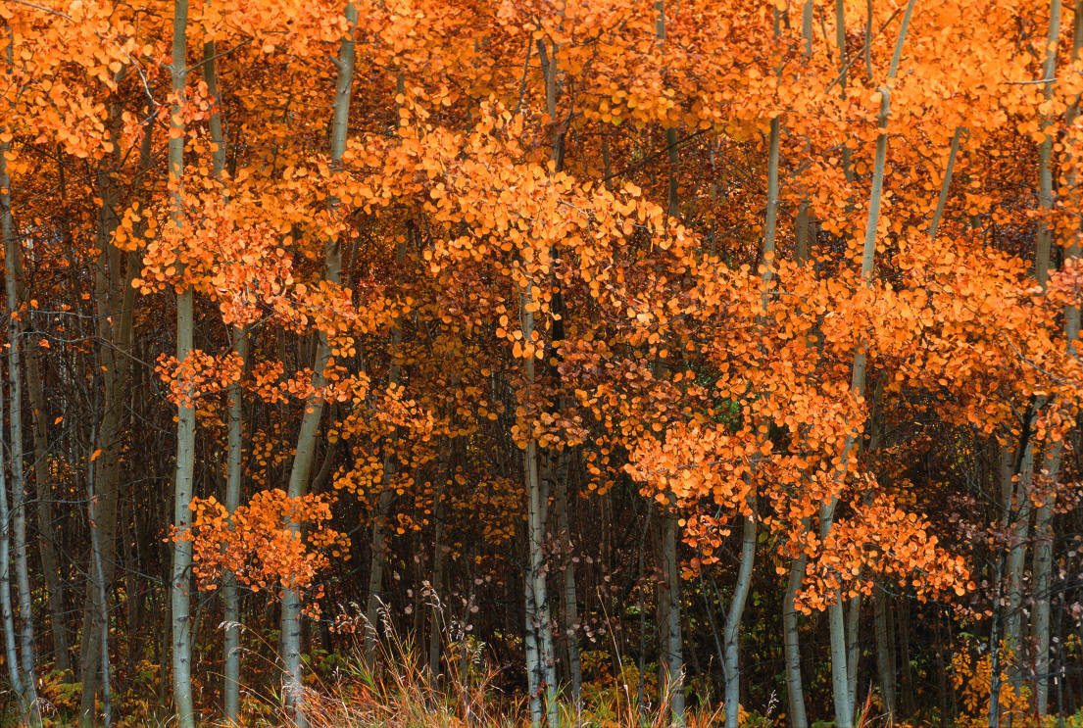
13th Anniversary

“Back to the Valley” Wine Tour
Saturday, November 30, 2013

10:30 a.m. to approximately 5:00 p.m.

That’s right folks. This is the 13th anniversary of our popular wine tour on Thanksgiving Saturday.

Meet at Tigard Fred Meyer. Bring some munchies to share, and we’ll tailgate somewhere along the line. There are lots of new wineries to check out!

We will rent a 12 passenger van for the day, so the cost will be $10 p/p. If we don't get 12 to sign up by NOVEMBER 26TH, we will just carpool, which will cut out this $10 fee.

Most wineries charge around $10 to taste, but if a purchase is made, the tasting fee is waived.

Join us for a day of tasting, food, music and fun. This group can guarantee you a good time! Contact Debbi Kor: ijustwannarun1@comcast.net to RSVP.



